

**Asset Practice Answers: Mathematics**

1. Anil wants to find his weight. So he stands on a weighing machine, but along with the bag he is carrying. He soon realises his mistake and this time stands on the machine, without his bag.

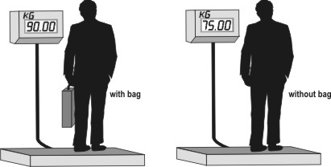

Clever Anil realises that the WEIGHT OF HIS BAG is

**A. 15 kg.** B. 25 kg. C. 90 kg. D. 165 kg.

2. Shown here is the information about the entrance tickets to an exhibition.

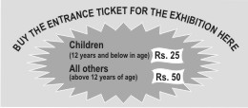

Some Class 4 students, all below 12 years of age, visit the exhibition. Which of these would be the correct way to calculate the amount of money they will have to spend on the tickets?

A. 12 x 25

B. number of students + 25

**C. number of students x 25**

D. number of students x 12 x 25

3. 1 apple and 2 oranges together weigh 330 grams. If each orange weighs 100 grams, how much does the apple weigh?

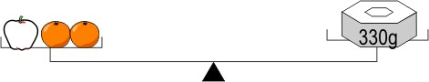

A. 30 grams

B. 100 grams

C. 110 grams

**D. 130 grams**

4. Manu had 5 spelling tests in a month. On each test, he scored 4 points more than the previous one.



If he scored 42 points on Test 5, how much did he score on Test 1?

**A. 26**

B. 30

C. 38

D. 58

5. After a cricket match in the Twenty 20 World Cup, a newspaper reported ''10 sixes hit by India in their innings. There were 15 fours as well.''

How many runs did India score through sixes and fours together in that innings?

A. 25

B. 100

**C. 120**

D. 150

6. Chanda bought some sweets to distribute to 7 of her friends. After giving 4 sweets to each friend, only

2 sweets were left with Chanda. How many sweets did she buy?

A. 13

B. 26

C. 28

**D. 30**

7. Nishchita had 18 pencils. After she put an equal number of pencils in 3 boxes, 3 pencils were left with her. How many pencils did she put in each box?

A. 0

**B. 5**

C. 15

D. 20

8. Kunal has some marbles. Adit gives him 23 more. Now Kunal has 39 marbles. How many marbles did

Kunal start with?

**A. 16**

B. 23

C. 39

D. 62

9. There are 25 children in a class. Each child was asked to name his or her favourite chocolate. The result is shown in the chart here.

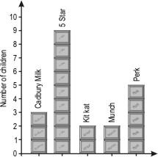

How many MORE children chose Perk than Cadbury Milk?

A. 8

B. 5

C. 3

**D. 2**

10. Some children voted for their favourite cartoon show. The number of votes received by different shows is shown in the table below.

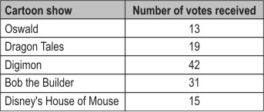

How many MORE votes did ''Bob the Builder'' receive than ''Dragon Tales''?

**A. 12**

B. 28

C. 31

D. 50

11. See the weighing shown below.

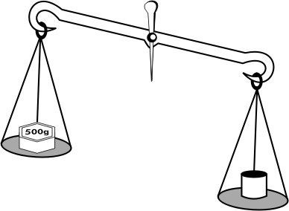

What could the weight of



be?

**A. 1 kg** B. 500 g C. 250 g D. 20 g

12. 25 children of a class went to the doctor for an eye check-up and were asked to read the letters from this chart:

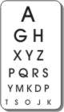

Study the chart and table to answer the question.

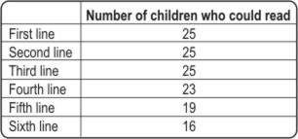

How many children in the class could NOT read the last line?

A. 11

**B. 9**

C. 6

D. 2



**Maths**

1. A: Anil's weight is 75 kg. The sum of Anil's weight and the bag's weight is 90 kg. That is if the bag's weight is added to Anil's weight, 75 kg, we get 90 kg. So what should be added to 75 to get 90? 90 - 75 = 15. So the weight of the bag is 15 kg.

2. C: From the figure we see that each child below 12 years of age has to pay Rs. 25 for the ticket. If 5 children visit the exhibition, how much do they have to pay? 5 x 25 rupees right? If 9 children visit, they have to pay 9 x 25 rupees. So how are we finding the total amount of money they will have to spend? The number of students x 25. 12 x 25 is the amount that 12 children will have to pay to visit the exhibition. Here we are not told that 12 children are going.

3. D: We are given that each orange weighs 100 grams. So 2 oranges would weigh 200 grams.The total weight of these 2 oranges and 1 apple is 330 grams. So the weight of the apple = total weight - weight of oranges = 330 - 200 = 130 grams.

4. A: Manu scored 42 points in Test 5. This is 4 points more than what he scored in Test 4. So in Test 4 he would have scored

42 - 4 = 38 points. Now this is 4 points more than his score in Test 3. So in Test 3 he would have scored 38 - 4 = 34

points. Similarly in Test 2 he would have scored 4 points less than 34, that is 30 points. In Test 1 he would have scored 4 points less than 30, which is 26 points.

5. C: Through the 10 sixes that India hit, they would have scored 10 x 6 = 60 runs. Similarly through the 15 fours, they would have scored 15 x 4 = 60 runs. So totally, they would have scored 60 + 60 = 120 runs through the sixes and fours together in that innings.

6. D: Chanda gave 4 sweets to each of her 7 friends. For this she will need 7 × 4 = 28 sweets. She has 2 sweets left with her after distributing these 28 sweets. So she should have bought 28 + 2 = 30 sweets.

7. B: We are told that 3 pencils were left with Nishchita after she put the pencils in the boxes. She had 18 pencils in all. So she put 18 - 3 = 15 pencils in the boxes. She put these 15 pencils in 3 boxes in such a way that there are an equal number of pencils in each box. So each box will have 15 ÷ 3 = 5 pencils.

8. A: 23 more than the number of marbles Kunal had is 39. So Kunal had 23 marbles less than 39. That is 39 - 23 = 16 marbles.

9. D: From the chart it can be seen that 5 children chose Perk and 3 children chose Cadbury Milk. So 2 more children chose Perk over Cadbury Milk. The question does not ask for the number of children who chose Perk. So B is not the answer.

10. A: From the table, "Bob the Builder" received 31 votes and "Dragon Tales" received 19 votes. So "Bob the Builder" received 12 more votes than "Dragon Tales".

11 A: If you take a heavier object and a lighter object and put them in two pans of a simple balance, what will you observe?

The pan with the heavier object tilts downwards. If



is heavier than 500 g weight, the pan containing it will tilt downwards as shown in the figure. So the weight of the given object is more than 500 g. 250 g and 20 g weights are less than 500 g. Hence A is the answer. If the weight of the object was 500 g, the two pans would be balanced and not tilted.

12. B: From the table, it can be seen that 16 of the 25 children could read the 6th line from the chart. So 9 (25 - 16) children did not read the last line (6th line). Check that 25 - 16 is 9 and not 11.